CHAPTER 1
Calculate:
a)
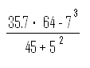

b)
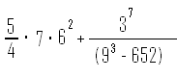

2. Calculate:
a)
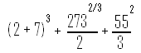

b)
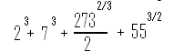
3) Calculate
a)
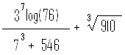

b)
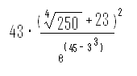
4. Calculate:

a)
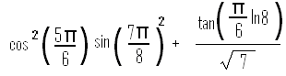

b)
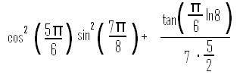
5. define the variable x as x =13.5, then evaluate:
a)
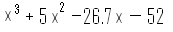

b)
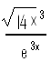
c)
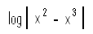

6. Define the variables x and z as x=9.6, and z=8.1, then evaluate:
a)
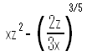

b)
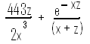

7. Define the variables a15.62, b=-7.08, c = 62.5 and d = 0.5 (ab – c).
a)
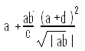

b)
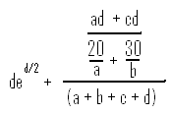
8) Calculate (by writing one command) the radius r of a sphere that has a volume of 350 in^3. Once r is determined, use it to calculate the surface area of the sphere.

9) Two trigonometric identities are given by:

- sin2x=2sinxcosx

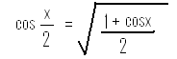
for each part verify that the identity is correct by calculating each side of the equation, substituting x=5/24*pi.

10. Two trigonometric identities are given by:

- 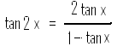
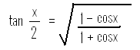
for each part verify that the identity is correct by calculating the value of the left and right sides of the equation, substituting x=3*pi/17.

11. Define two variables: alpha = 5*pi / 9, beta=pi/7. Using these variables, show that the following trigonometric identify is correct by calculating the value of the left and right sides of the equation.

cos(alpha) – cos(beta) = 2sin1/2(alpha + beta)sin1/2(beta – alpha).

- In the right triangle shown a=11 cm, and c=21 cm. Define a and c as variables, and then:

  - Using the Pythagorean Theorem, calculate b by typing one line in the command window.
  - Using b from part a), and the acos(x) function, calculate the angle alpha in degrees, typing one line in the Command Window.

13. In the triangle shown a=18 cm, b=35 cm, and c=50 cm. Define a, b, and c as variables, and then calculate the angle gamma in degrees by substituting the variables in the Law of cosine.
(The law of cosines : c^2 = a^2 + b^2 – 2abcosγ)

γ = cos^-1(-c^2+a^2 + b^2)/2ab

- The distance d from a point (X0, Y0) to a line Ax+By+C = 0 ins given by
` d = ! Axo + Bxo + C ! / sqrt (A^2 + B^2)

Determine the distance of the point (2, -3) from the line 3x+5y – 6 = 0. First define the variables A, B, C, Xo, and Yo, and then calculate d. (Use the abs and sqrt functions.)

- Flowers are packed in boxes such that a dozen are placed in each box. Determine how many boxes are needed to pack 751 flowers, using the ceil function.

- Define the following variables:
tables_price = $256.95
chair_price = $89.99
Then change the display format to bank and:
- Evaluate the cost of two tables and eight chairs.
- The same as part a) but add 5.5% sale tax.
- The same as part b) but round the total cost to the nearest dollar.

- When adding fractions, the smallest common denominator must be determined. For example, the smallest common denominator of 1/4 and 1/10 is 20. Use the MATLAB Help Window to find a MATLAB built-in function that determines the least common multiplier of two numbers. Then use the function to show that the least common multiplier:
  - 4 and 10 is 20.
  - 6 and 38 is 114.
- The magnitude M of an earthquake on the Richter scale is given by:
M=2/3logE/E0, where E is the energy released by the earthquake, and E0=10^4.4 joules is a constant (energy of a small reference earthquake) Determine how many times more energy is released from an earthquake that register 7.2 on the Richter scale than an earthquake the registers 3.3.

